**Project Based Learning (PBL) Report**

**For the course**

**Internet of Things-20CS32001**

**BACHELOR OF TECHNOLOGY**

IN

**COMPUTER SCIENCE AND ENGINEERING**

N.Karthik-23R15A0521

N.Aryan-23R15A0522

D.Damarendarnath-22R11A05k6

Under the Guidance of E Mahender



Department of Computer Science and Engineering

Accredited by NBA

Geethanjali College of Engineering and Technology

(UGC Autonomous)

(Affiliated to J.N.T.U.H, Approved by AICTE, New Delhi) Cheeryal (V), Keesara (M), Medchal.Dist.-501 301.

JUNE -2025

| S.No | Index | Page No. |
| --- | --- | --- |
| 1 | ABSTRACT | 3 |
| 2 | INTRODUCTION | 4 |
| 3 | SYSTEM DESIGN | 5 |
| 4 | IMPLEMENTATION | 7 |
| 5 | OUTPUT | 8 |
| 6 | CONCLUSION | 9 |
| 7 | REFERENCES | 10 |

This project presents a basic yet effective **Rain Detection System** using an **Arduino Uno**, a **rain sensor**, and an optional **buzzer or LED** for alerting purposes. The primary goal is to detect the presence of rainfall and respond accordingly through a visual or audible signal. The system utilizes an analog rain sensor module connected to one of the Arduino’s analog pins to monitor moisture levels. The sensor produces varying voltage outputs depending on the amount of water present on its surface.

The Arduino reads the analog value from the sensor and compares it against a predefined threshold (e.g., 500). If the value drops below the threshold, it indicates the presence of rain. The microcontroller then activates a connected buzzer or LED to alert the user. If the reading is above the threshold, it means no rain is detected, and the output device is turned off. The sensor data and rain status are also printed to the Serial Monitor, providing live feedback for debugging or monitoring.

This system is programmed to take readings every 2 seconds to provide up-to-date weather conditions in real time. It is power-efficient and easy to deploy, making it suitable for various real-world applications.

With the growing need for smart automation in both domestic and industrial applications, weather-responsive systems have become increasingly important. Among various environmental factors, **rainfall detection** plays a key role in managing resources, protecting equipment, and ensuring safety. Traditional methods of detecting rain often involve manual observation, which is neither reliable nor efficient. To address this gap, microcontroller-based rain detection systems offer a low-cost and automated solution.

This project introduces a simple yet effective **Rain Detection System using Arduino Uno** and a **rain sensor module**. The system is designed to sense rain in real-time and provide instant alerts using an LED or buzzer. It continuously monitors moisture levels on the sensor’s surface and reacts when rainfall is detected based on a predefined threshold value. The Arduino processes the analog input from the sensor and provides both a **visual/audible alert** and a **serial output** for logging or further processing.

Such a system finds use in **smart irrigation**, **automated home control systems**, **greenhouse management**, and **weather monitoring setups**. By offering a compact, cost-effective, and scalable solution, this rain sensor project serves as a foundational component for more complex Internet of Things (IoT) applications and embedded systems.

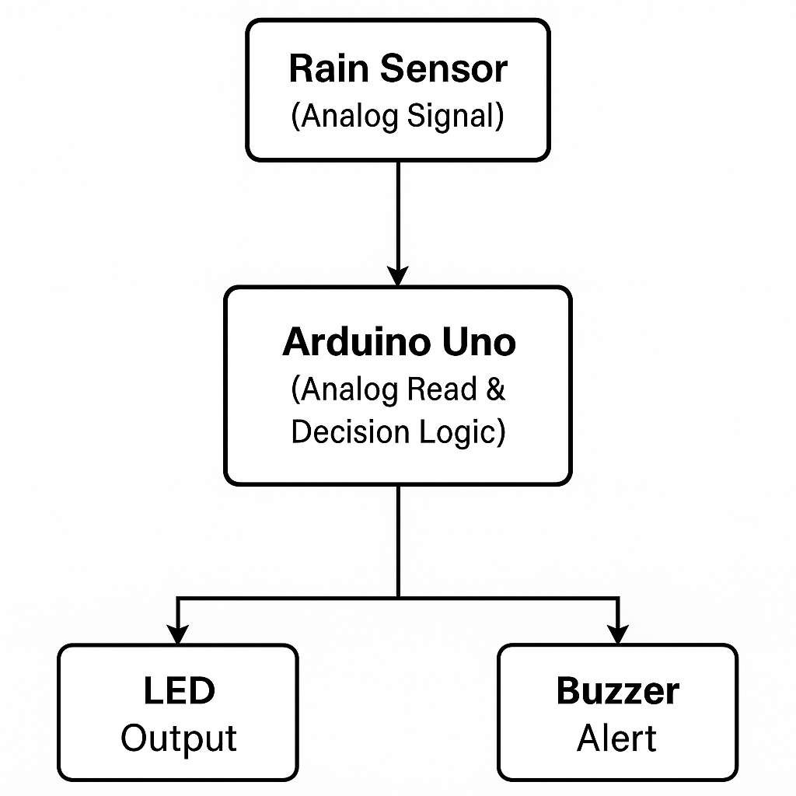

// Pin Definitions

const int rainSensorPin = A0; // Analog pin connected to rain sensor const int buzzerPin = 7; // Optional buzzer or LED

// Rain threshold (adjust based on testing) const int rainThreshold = 500;

void setup() { Serial.begin(9600);

pinMode(rainSensorPin, INPUT); pinMode(buzzerPin, OUTPUT);

}

void loop() {

int sensorValue = analogRead(rainSensorPin);

Serial.print("Rain Sensor Reading: "); Serial.println(sensorValue);

if (sensorValue < rainThreshold) { Serial.println("🌧 Rain Detected!");

digitalWrite(buzzerPin, HIGH); // Turn on buzzer/LED

} else {

Serial.println("☀ No Rain.");

digitalWrite(buzzerPin, LOW); // Turn off buzzer/LED

}

delay(2000); // Check every 2 seconds

}

# 6. OUTPUT

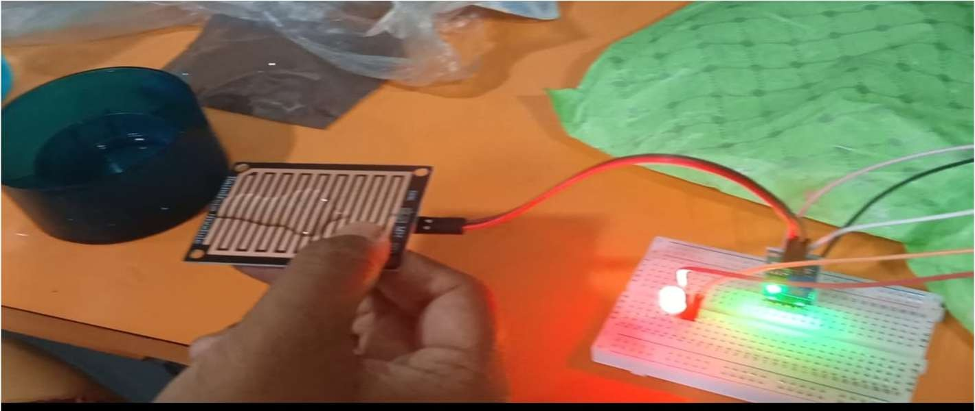

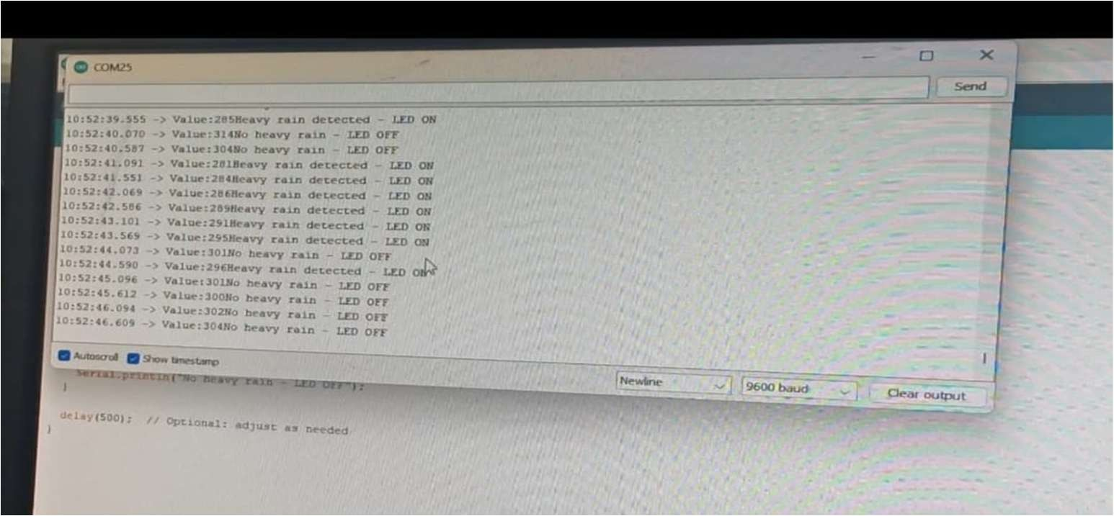

The Rain Detection System developed using Arduino Uno, a rain sensor module, and a buzzer/LED successfully demonstrates the ability to **detect rainfall in real-time** and provide immediate alerts. The project highlights how simple hardware components, when integrated with microcontroller logic, can be used to build an efficient and responsive weather- monitoring tool.

This system offers a **cost-effective**, **reliable**, and **scalable solution** for various applications including smart agriculture, home automation, and environmental monitoring. The serial output also allows for easy integration with data logging or IoT platforms for future enhancements. Overall, this project serves as a foundational step toward building more advanced weather-based automation systems and introduces students and beginners to real- world embedded system design.

* https://[www.sciencedirect.com/science/article/pii/S2665917423002131](http://www.sciencedirect.com/science/article/pii/S2665917423002131)
* https://[www.e3s-conferences.org/articles/e3sconf/pdf/2023/28/e3sconf_icmed-](http://www.e3s-conferences.org/articles/e3sconf/pdf/2023/28/e3sconf_icmed-) icmpc2023_01150.pdf
* https://[www.azosensors.com/article.aspx?ArticleID=2958](http://www.azosensors.com/article.aspx?ArticleID=2958)